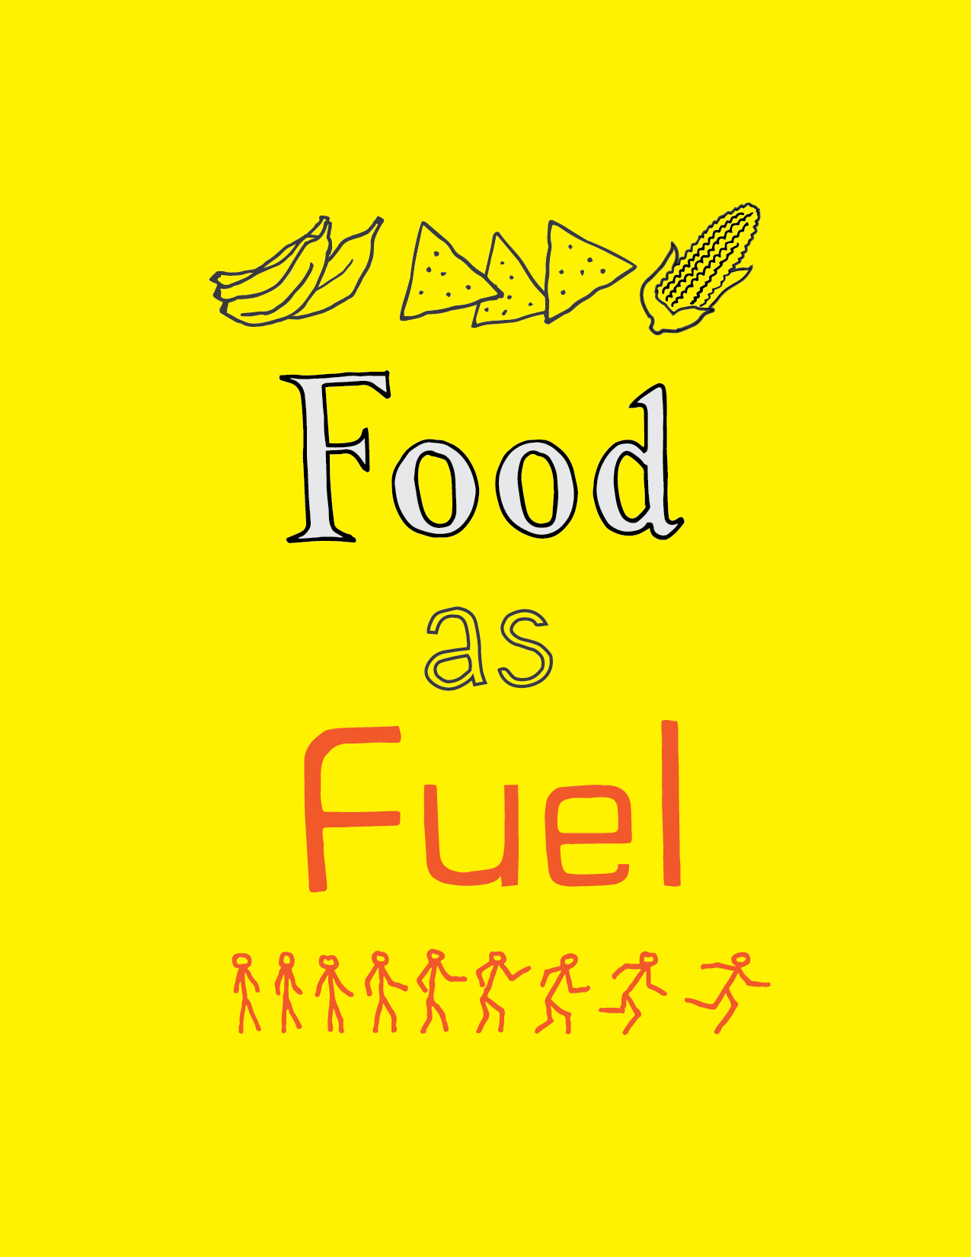

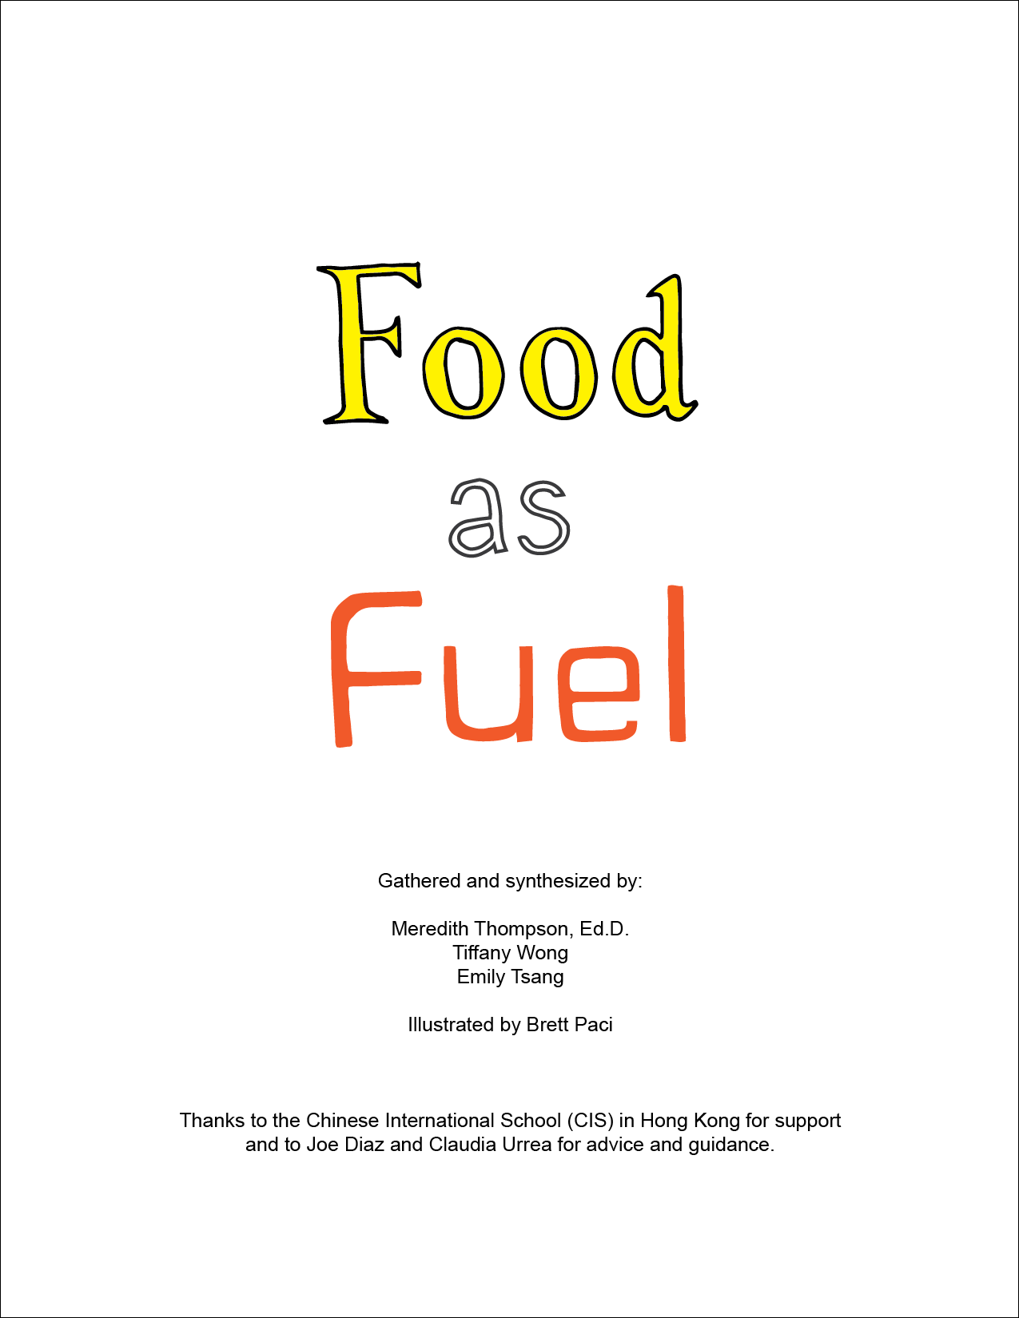

## **Food as Fuel Overview and Learning Objectives**

1. Students will be able to (SWBAT) categorize energies into chemical energy, potential energy and kinetic energy.
2. SWBAT discuss the conservation of energy and draw energy maps of their day
3. SWBAT do proportional reasoning to calculate energy intake and spent

|  |  |  |  |  |
| --- | --- | --- | --- | --- |
| Activity | Time | Obj. | Goal | PD (30) |
| Do now: discuss what is energy  Introduce goal and big concepts. | 20 | (1) | Warm up. Get students to think about energy from their own experience. Educator will bucket it into PE/KE/CE and use it as a springboard for introducing the module. | Learner-Centered Instruction  Backwards planning |
| Connect concepts to “food as fuel”; How does food provide us with energy? Create personal energy map | 25 | (1)  (2)  (3) | Introduce the concept of tabulating the energy we get from food into potential energy we can use later. Introduce the “Puzzle” for students to fill in balance sheet. Refer back to it for entire workshop. | Playful approaches to learning  Connecting learning to life  Collective Intelligence |
| What you choose to eat matters too! | 5 | (2)  (3) | Some foods take more energy to digest = you use calories just adding the food calories to your body.  Edit the balance sheet to account for different types of food. | Playful approaches to learning  Connecting learning to life |
| Plan your snack | 15 | (3) | Student gets to pick X calories of snacks. Fill in puzzle with food calories. | Playful approaches to learning  Connecting learning to life  Designing solutions to open ended problems |
| **SNACK TIME!! :)** | | | | |
| Run with Fitbit/iPhone | 30 | (2)  (3) | Students can estimate how to energy they spend during activities to fill in energy map | Integrating technology, Playful approaches to learning  Collective Intelligence |
| Meditation | 10 | (2) | Students learn about Basal Metabolic Rate in their body | Strategies for handling stress |
| Balance Energy Map | 10 | (2) | Always using energy (even in sleep). Unbalanced sheet → student explores possible answers (basal metabolic rate | Designing solutions to open ended problems |
| *Hack your snack* | 30 | (1)  (2)  (3) | (1) Students come up with their ideal, indulgent snack. (2) Calculate calories and figure out how to burn all those calories (3) Share with the class | Playful approaches to learning  Collective Intelligence |

The remaining of the document includes:

* Teacher guides for activities with Professional Development embedded
* Student handouts for activities (where applicable)
* Parent handout for additional activities and resources
* Professional Development analysis of the activities

**This module embodies STEAM in this way**

S: Scientific concepts such as energy conversion, conservation of energy, understanding and relating the concept of “calorie” to energy, digestion, scientific practices including asking questions, planning investigations, collecting and analyzing data, communicating results.

T: Use of technology to extend the capability of students to explore the world, specifically by using a caloric monitor to track energy expenditure during exercise.

E: Identifying a problem (How can I understand food consumption in terms of energy?) Breaking problem down into measurable parts, using mathematical and scientific concepts to solve the problem. Demonstrating that there are multiple ways (food choices and exercise choices can be different). Viewing the body as a system that can be understood and adapted.

Problem designed with limitations. Goal. how do you solve it? Being creative!

A: Emphasis on artful presentation and documentation of lesson ideas and worksheets. Visualisation. How is food as energy.

M: Enumerating problems mathematically and solving problems (food consumption and energy expenditure) Using proportional reasoning to understand food choices and application towards energy balance.

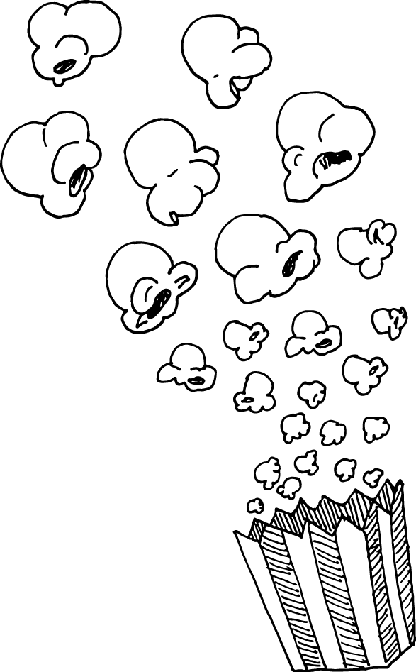

### 

### **Do now: Discuss “What is energy?” (20 minutes)**

Instructions 2 minutes

Writing down ideas 3 minutes

Synthesizing ideas together 5 minutes

Introduce module goal 5 minutes

Time for questions 5 minutes

**Required materials**

* Some place to write down students’ ideas (White board etc)

**Instructions**

*Writing down ideas about energy*

Introduce yourself by name and explain the goal of the module is to discuss energy. Ask students to raise their hands if they have ideas about energy (raise own hand to demonstrate).

Possible talking through - Great! We are curious about those ideas! So now let's think about energy in two categories: energy that is stored and energy that is used [write down "energy stored" and "energy used" on the board]. Now let's go back to the ideas we thought about earlier. [go through the things written on the board and categorize them as stored or used]. Can you think of more ideas that can go under energy stored? [write them down] Can you think of more ideas that can go under energy used? [write them down] This looks awesome! So today in talking about energy, we are going to discuss the energy of our bodies. [Say this if food was not mentioned already] Similar to [use an example that a student came up with], our body also gathers and uses energy. What is this energy known to us as? [ask students to raise hands and give answers] Food! And how can we know how much energy is in a specific food item? [ask students to raise hands and give answers] In the same way that we say inches to measure length or pounds to measure weight, we use calories to measure how much energy is in a food. So that's on the "energy stored" side, and what goes on the "energy used" side? [ask students to raise hands and give answers] Some things on this side include: your BMR which stands for Basal Metabolic Rate, which is the energy used to do things like blink, breathe, and make your heart beat, digest, and grow.

So our goal by the end of this lesson is for all of you to have a better understanding of how food in the form of energy is stored and used in the body, and to do that we are going to do several activities today

*Synthesizing students’ ideas and introducing big energy concepts*

Explain that we are going to explore energy today - specifically, the energy that we gather and use to power our bodies through the day. At the end of the day, we want you to be familiar with a few important ideas about energy, and to understand how these connect to food so you can make informed choices about food.

### **Food as Fuel - The big ideas**

Instructions:

*Give students the big picture of the lesson;* Here are the big ideas we are going to cover today.

**Big idea #1: Action energy is called kinetic energy** - We had lots of ideas about action energy. When scientists and engineers talk about moving energy they call it kinetic energy. Today we are going to experience kinetic energy when we do exercise in the afternoon.

**Big idea #2: Stored energy is called potential energy**. Potential energy is stored energy for us to use later on. This morning we will eat a snack. The energy that we get from that snack will be stored by our bodies and we will use it in the afternoon for action!

**Big idea #3: Energy is transformed from one form to another.** We don’t create or destroy energy - all energy gets changed into different forms. Not all of the potential energy in the food we digest is used for activity or stored for later - some of it is given off as heat energy. But it does not disappear - it just gets changed into a different form.

**Big idea #4: Energy in is energy out.**  We don’t create or destroy energy - all energy gets changed into different forms. Not all of the chemical energy we digest is used for activity or stored for later - some of it is given off as heat energy. But it does not disappear - it just gets changed into a different form.

Resources: [Types of energy](https://www.enwin.com/kids/electricity/types_of_energy.cfm)

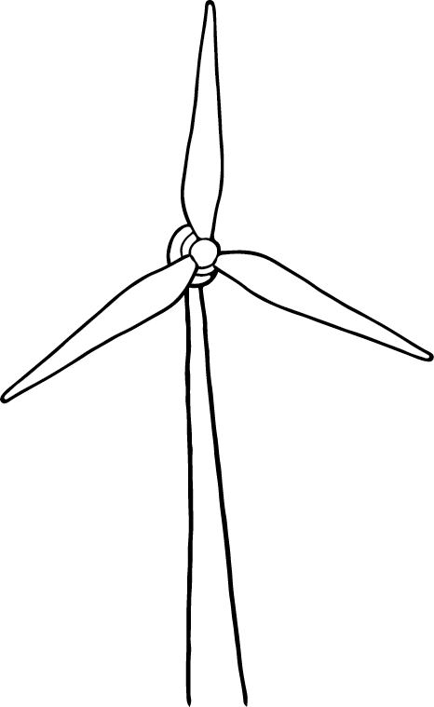 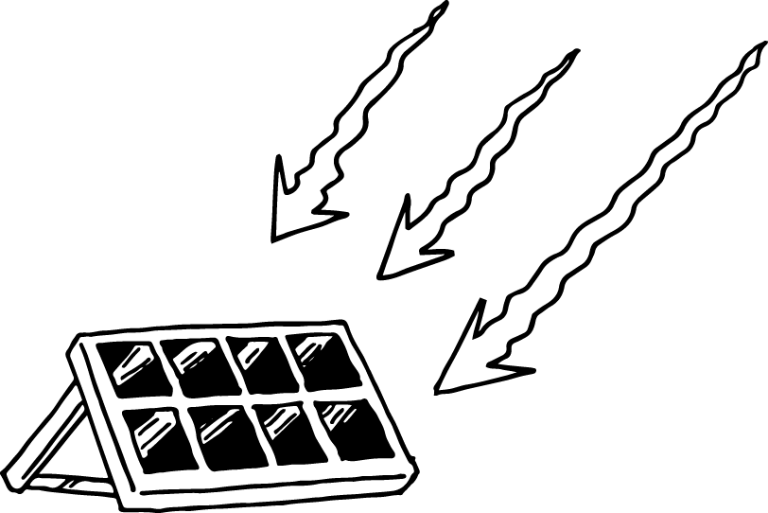

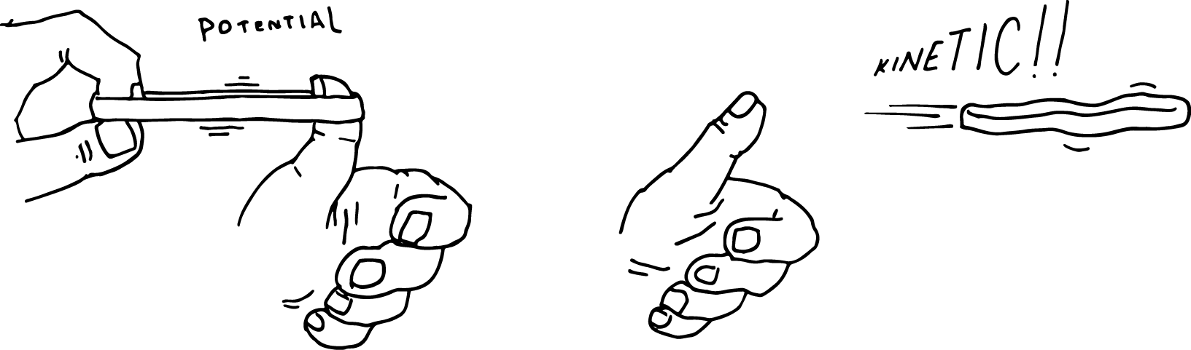

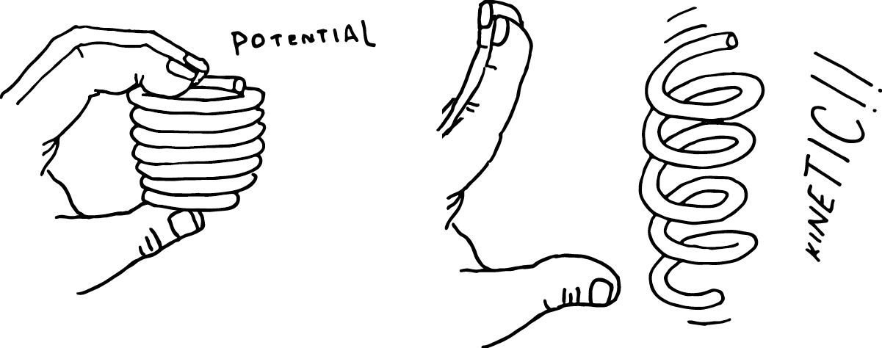

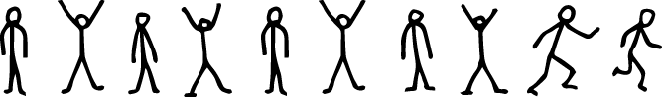

### **How food energy becomes energy you can use (20 minutes)**

**Learning goals**

1. Students will understand that energy in food is stored as **chemical energy** in the chemical bonds - both in the food itself and in our body.
2. Students will understand that the energy in food is measured as **calories.** The more calories that are in the food - the more energy that food can give.
3. Students will learn a very little about the process of digestion (not too detailed) and understand that **chemical energy is transformed** from one form to another in the body  
   Note: Here’s an example of the level of detail we may cover about [digestion](https://ourworld.unu.edu/en/how-things-work-food-energy).
4. Level 2 students will also learn…..
   1. Students will learn that digested food travels through the bloodstream to cells.
   2. Students will learn how the mitochondria in cells (the energy factory) turn energy from food into energy that can be stored as **potential energy**.
   3. Students will learn that the bonds in the stored energy are broken and **the energy is transferred from potential energy into kinetic energy**.
5. Students will understand that **energy is transformed** - if they eat too many calories then the body will store those calories as fat.

**Instructions**

[**Digest this! A role play**](https://docs.google.com/presentation/d/1VqJDHQstaZ7dsDHPy0mS_Hv_hsWai10ZyuJOE-_cm14/edit#slide=id.g1f7e1ebd66_0_84)

Use [this link](http://www.innerbody.com/image/digeov.html#full-description) to view the role play - include where the proteins, carbohydrates, and fats are located.

Now that we have learned a little bit about the digestive system, we are actually going to do a role play! Some of you will role play different parts of the digestive system, and others will role play different types of food: carbohydrates, protein, and fat.

Then, we will do a game (to be found or developed) or a role play where different students represent different forms of energy, and we will represent the different steps of transferral.

[Interactive digestion game](http://interactivehuman.blogspot.com/2008/05/digestion-interactive-game-for-kids.html) (US) - this has information on how different types of foods are digested

[Build a body game](https://www.brainpop.com/games/buildabodydigestivesystem/) - Brainpop (requires Flash)

[Interactive step by step game about digestion](http://splash.abc.net.au/res/i/L1/index.html) (Australia)

[How does our body change food into energy we can use](http://www.livestrong.com/article/496198-how-does-our-body-change-food-into-energy-we-can-use/)

[How our bodies turn food into energy](https://www.ghc.org/healthAndWellness/?item=/common/healthAndWellness/conditions/diabetes/foodProcess.html)

[How cells obtain energy from food](https://www.ncbi.nlm.nih.gov/books/NBK26882/)

This is a fun video about the Digestive System that covers this material.

[Digestive System Part 1: Crash course](https://www.youtube.com/watch?v=yIoTRGfcMqM) (11 minutes long)

The energy we get from food is released from the chemical bonds in the food molecules.

### 

Carbohydrates (above) have carbon molecules and water. This is table sugar!

### 

Lipids have long chairs of carbon and hydrogen.

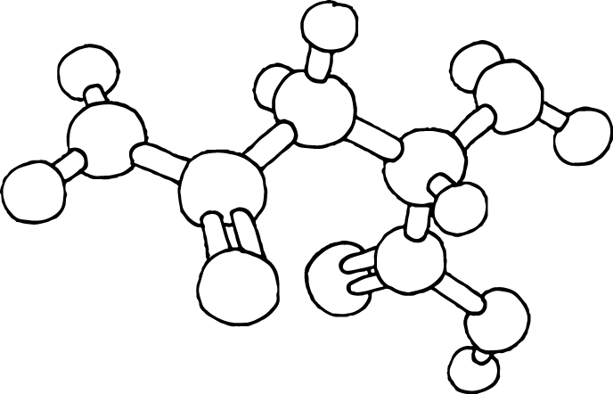

Amino acids are the building blocks of proteins. Proteins are well known for their ability to fold, and are important sources of energy.

### **Hold on! What you eat matters too! (5 minutes)**

**Learning goals:**

1. Students will learn how to identify a whole food and a processed food.
2. Students will learn three kinds of foods: proteins, carbohydrates, and fats.
3. Students will learn that the body uses energy (calories) in the process of digesting different types of food.

Level 1: Different types of food take different amount of calories to digest - whole foods take more calories to digest, processed food takes fewer calories to digest.

Level 2: Different types of food take different amount of calories to digest. Whole foods take more calories than processed food.

Protein: 20-30% of calories in protein are used during digestion

Carbohydrates: 5-10% of calories in carbohydrates are used during digestion

Fats: 0-3% of calories in fats are used during digestion.

### [Why food is not just fuel - energy needed to digest food](http://www.huffingtonpost.com/john-berardi-phd/why-the-food-is-fuel-anal_b_6815880.html)

[Digesting protein takes more calories than digesting carbs or fats](http://www.precisionnutrition.com/digesting-whole-vs-processed-foods)

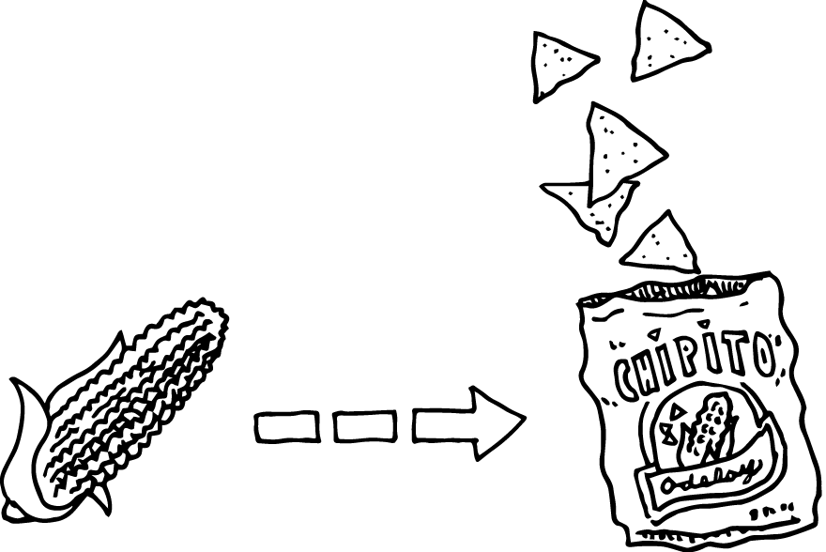

### Teacher level info

[Whole food versus processed food](https://www.ncbi.nlm.nih.gov/pubmed/20613890) - difference in digestion (research report - high level science)

[Understanding whole foods](http://www.nutritionmd.org/nutrition_tips/nutrition_tips_understand_foods/whole_advantages.html)

*Whole foods tend to be healthier than processed foods* Whole foods are foods like fruits, vegetables, grains - foods that are minimally processed. Whole foods tend to contain more nutrients such as vitamins and minerals, and less sugar and fats than processed foods. Whole foods are often not packaged, although grains such as rice and oatmeal often are sold in packages.

*Calories are also used in digestion.* The body actually uses calories to digest different types of food - so that energy is used when it enters the body and is not available to store or to use later. It’s not only the number of calories in the food but also the type of food it is that matters in how much energy gets stored for future use.

### 

### 

### Plan your snack (20 minutes)

**Explain to students:** At this point, we will introduce the idea that we are going to create a personal energy map (design to be created) to use the ideas of **tapping into the potential energy** that the body has stored as a result of food and **converting the potential energy into kinetic energy** during exercise. With this information in mind, the students will investigate which food they want to select for snack.

We will have a variety of snacks available - the fruits and vegetables can be selected to be in season to save money. For level 1 all of the food options should be portioned into single servings to make calculations quickly/ Level 2 students can have multiple servings and have to calculate a single serving as an extra challenge. Any food that does not have a label (such as the fruit and vegetables) should be accompanied by a sign that states the calories in a single serving of the food. *For level 1 the signs should just contain the relevant information such as “calories per serving”. This sign could be a “Nutritional Value” sign for Level 2, so that the students would have to find the calories among all of the different data presented on the label.*

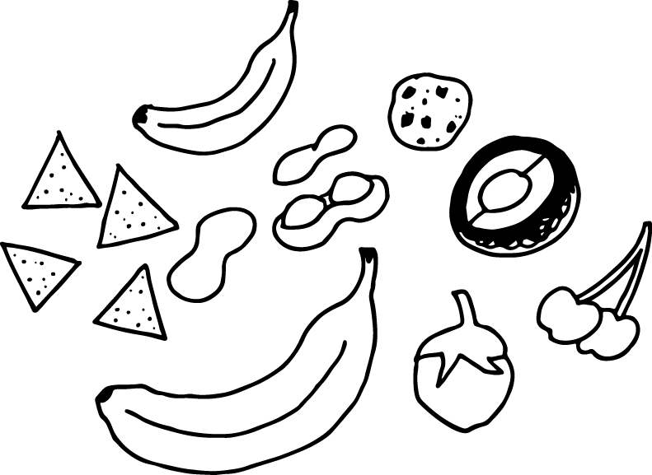

**Ideas for food**

**Fruits** such as oranges or clementines, bananas, apples, watermelon slices, ideally of the same width and weight. For level 2, more challenging choices could be grapes, watermelon that students would have to weigh and calculate the calorie count.

**Vegetables**

Fruits and vegetables. Snack packs. Bananas. Selections of chips. Chocolate. Candy bars.

Explain to the students that they have to consider how many calories are in each snack, and think about how many calories they will burn in the afternoon. Together, we will calculate how much energy the snack will give us for the afternoon, and then calculate how much energy we have used in the activities.

*Learning goals: Students will learn how to use evidence from labels to select foods as well as* [*online calorie calculators*](http://www.webmd.com/diet/healthtool-food-calorie-counter) *.*

*Students will create a personal energy map, similar to an activity like this* [*How to Choose Healthy Snacks*](http://www.wikihow.com/Choose-Healthy-Snacks)

*Students may play a game* [*FDA snack games*](https://www.fda.gov/Food/IngredientsPackagingLabeling/LabelingNutrition/ucm490204.htm) *like the* [*Whyville Snack Shack*](http://www.whyville.net/smmk/top/gates/flax) *(time permitting)*

*Students will then plan out their snacks for the afternoon. Teachers can also participate in this activity, demonstrating how they “join the community of learners” in investigating food and exercise choices.*

Resources:

[Smart snacking for kids](http://kidshealth.org/en/teens/healthy-snacks.html)

[Snacks and Games! Visit the Snack Shack today!](https://www.fda.gov/Food/IngredientsPackagingLabeling/LabelingNutrition/ucm490204.htm)

[Using the nutrition facts label](https://www.fda.gov/food/resourcesforyou/consumers/ucm267499.htm)

[Food calorie counter - WebMD](http://www.webmd.com/diet/healthtool-food-calorie-counter)

### 

### 

### Activity Time - Kinetic Energy (30 minutes)



At MIT, students love to learn new things, especially things that can be useful in solving problems. This afternoon we will make learning a fun activity by doing different types of exercise.

**Plan**

Instructions 5 minutes

Exercise + Relocation 20 minutes

Fill in table 5 minutes

**Required materials**

* [1 monitor / 2 students](https://www.amazon.com/dp/B00EKPXJTU/ref=twister_B01DENG4UO?_encoding=UTF8&psc=1)
* Open space for movement

**Instructions**

There is still one portion of the Energy Map that has yet to be filled out -- calories used by the body during activities/exercises throughout the day. Students will take turns doing activities with a heart rate monitor to quantify the number of calories burned during the activity. This will be the student's’ opportunity to understand and gain intuition on how much calories are consumed when they run or jump or do internal training. The pairs of students will stay together during the activity; the student wearing the heart rate monitor will be doing the activity while the student not doing the activity will record their partner’s heart rate at different points in time.

Level 1 activities should be relatively simple to calculate such as running a set distance, jumping a certain number of times, climbing the same amount of stairs. The heart rate for these activities should be taken at the end of the activities, just at the very beginning moment of “cool down”.

Level 2 activities could include an introduction to high intensity interval training (HIIT), a type of exercise where the individual alternates high intensity activity with less intensity activity. For example, instead of running at the same pace for 45 minutes, a person doing a HIIT workout would run at top speed for 2 minutes then jog slowly for 5 minutes, then repeat that cycle. This type of exercise involves raising and lowering the heart rate multiple times; Level 2 students could be challenged to graph the heart rate over time.

Give students an overview of the activity, then ask the students to estimate - how many calories do you think you will burn in 5 minutes of running? Write that number down on the calorie counter sheet. How many calories do you think you will burn in 5 minutes of jumping? How about 5 minutes of yoga? Tell them to do this on their own, and once they have written something down they can talk to their partner to see what they thought.

*Developing practice in estimating parameters for ill structured problems.* If the students have difficulty estimating the number of calories, you can have them estimate a number they are sure is much bigger than the number of calories and then another number that is likely to be way too few calories, and then a third number that they think could be just about right. The idea of estimation and “back of the envelope” type calculations can be useful tools in science and engineering, since often real world problems are not well defined.

Explain that we will be moving to an open area, so it’s important to listen carefully to the instructions before we leave the classroom/ room.

**Exercise + Relocation**

Students will relocate to an open area. They will be split into groups of 2 (or 3) and given one heart rate monitor per duo.

Each member of the team will engage in some physical activity - jogging, pushups, jumping jacks - see the worksheet. Students will make note of how many calories are burned after their short (5 minute) workouts.

**Fill in Table**

After the activities are finished, students will give their partner the heart rate monitor readings, then students will use their heart rate and their personal information (age, weight) to calculate how many calories they expended during the activity. Students will then return to their Energy Maps and use their heart rate to calculate how many calories they have expended.

*Checking for understanding among students/ formative assessment -* Now is a great time to do some formative assessment*.* As students are doing these calculations, circle around and check on the pairs of students. Check their work on the papers and see if there are any students who are confused. For the students who are on track, you can ask them to think more deeply about the activity (and simultaneously assess what students are learning) by asking them questions. Some example questions could be “How many calories did you burn? Does the number of calories match the estimate you had at the beginning of the activity? Is it fewer calories or more calories? What do you think of these results?” You can also ask them to estimate other parameters such as their own perception of being tired, and how their own workouts compare to these mini workouts. Do they feel more tired? Do they feel their heart rate more or less?

*Calories burnt during exercise = calories burnt running * (length of exercise in mins / 5 mins)*

**Discussion**

5 minutes of exercise can burn different amounts of energy/calories depending on:

* Type of workout
* Person doing the workout
* What other factors? Have students give suggestions.

The mathematics here includes proportional reasoning as well as estimating to calculate calories burnt during a given exercise. Start by asking students questions such as “When you exercised more vigorously, was your heart rate lower or or higher?” Then be sure students relate heart rate to energy burned. Note to the students that heart rate is an example of evidence that can be used to estimate calories being expended.. Students in Level 2 could even plot their heart rate on a graph.

Next it is useful for students to think of other factors that may influence the calories burned during the activity: age, weight, height (as it relates to weight), level of fitness. You can ask, for example “What are some other factors that could influence how fast your heart beats during exercise?” Give time for the students to come up with answers to this question. It is likely that someone will mention weight or mass and age here, but if they don’t you can ask “What would happen if we put on a very heavy backpack. Would your heart pump harder to catch up or slower?” Then connect the heavy backpack to having more weight to carry around on a person. For age you can ask “Who seems to have more energy - you or your parents?” Then relate energy level to age.

Note: Whenever possible, give students time to come up with suggestions - try to have the students’ ideas be at the center of the lesson. Having students’ ideas and voices as a part of the lesson is one pathway to a learner centered classroom.

### Meditation (10 minutes)



Here it would be good to summarize what we have learned so far. By now, students should have the idea that more vigorous exercise leads to a higher heart rate, which burns more calories. There are other factors that also influence heart rate including age, fitness, and weight.

In the next activity, we will examine how much energy it takes for us to do nothing. We will start with a meditation activity. During the activity, ask students to take long, slow breaths, and as they are doing so, to pay attention to their breathing. Students should also pay attention to their heart rate, how many times they are blinking, how many times they may be swallowing, and even the energy they need to sit up straight.

**Activity timeline**

Meditation 5 minutes

Discussion 5 minutes

**Overview**

Instructor will lead students through 5 minutes of meditation. During that time the instructor will ask students to notice their heart rate, their breath etc. They will then discuss

* the metabolic basal rate (middle school)
* the idea that energy is constantly being burned in the body (primary school)

**Meditation**

Students will either sit cross-legged on the floor or on a chair with their back straight. Their eyes should be closed to minimize distractions and no talking should occur.

The instructor will guide the students in picturing their breath and noticing their heart rate. One simple method of meditating is to count their breath, start from 1, 2, 3 … 10 then starting again from 1. Encourage students to free their mind of any distractions. They should not be avoiding thoughts as those are natural, but attempt to ignore them when thoughts surface. As preparation, instructors are encouraged to use Headspace and follow along their 10 minute meditations.

**Discussion**

At the end of the meditation period, ask the students “Do we really ever do nothing? What is our body doing, even when we are doing no particular activity?” Students may come up with ideas such as breathing, blinking, standing, sitting, holding your head up, heart beating. One thing to mention that students may not come up with is growing. From when they were babies to now, the students have grown a lot, and they are still in the process of growing. Impress upon them that it also takes energy for the body to create new parts.

Explain to the students that the energy you need to just keep the body going is called Basal Metabolic Rate (BMR). Your metabolism is the processes that happen within the body in order to keep the body alive. Basal is a fancy word for saying “the bottom or lowest part”. Rate is the speed over time, like your heart rate is how fast your heart was beating over time. These three words describe the lowest amount (basal) of energy you need in order to keep your body going (metabolic) at a certain level (rate).

Each student should look up their BMR on a table. Level 2 students can use a formula to calculate their BMR from this page: [formulas to calculate BMR for different ages](http://www.topendsports.com/weight-loss/energy-bmr.htm). For an added challenge, Level 2 students can estimate their BMR accounting for their activity level overall using the [Harris Benedict Equation](http://www.bmi-calculator.net/bmr-calculator/harris-benedict-equation/). This table begins at age 10. Students in Level 1 should use a [BMR online calculator](http://www.bmi-calculator.net/bmr-calculator/) to calculate their BMR. Note that students may need to know how much they weigh and how tall they are, so it would be good to bring a digital bathroom scale so students can check their weight if they do not know it and a tape measure so students can check their height.

There is a study that shows [yoga practitioners to have a lower basal metabolic rate than those that do not practice yoga](https://www.ncbi.nlm.nih.gov/pmc/articles/PMC1564415/). This decrease in BMR has been attributed to lower arousal. Our body is constantly burning energy. The minimum amount of energy required for bodily functions, including heartbeat and breathing.



### Balance Energy Map (10 minutes)

In this activity, students will complete the remaining sections of their energy balance map, making sure they have noted the calories for their mid session snack, the heart rate and calories for their exercise, and their basal metabolic rate (BMR).

Using these parameters, we want students to use the big idea that “energy is transferred from one type to another type of energy”. Students will figure out how of that snack they were able to “burn” during the activity. Any calories that are not burned will become “potential energy” and be stored in the body for when we next need energy. In this way, the energy that we obtain from food either goes towards activity (transformed into kinetic energy) or is stored by the body (transformed into potential energy).

As students complete the remaining sections of their energy balance map, be sure to circle around the room and see if students have questions.

They will calculate the Metabolic Basal Rate using an [online calculator](http://www.bmi-calculator.net/bmr-calculator/#result).

Bonus: They can also calculate their daily caloric needs using the [Harris Benedict Equation](http://www.bmi-calculator.net/bmr-calculator/harris-benedict-equation/).

Ideally, their energy maps will balance at the end of this activity - the energy in the food gets used either as kinetic or stored as potential energy.

### Hack Your Snack (30 minutes)

Hacking is a playful activity that is a part of the MIT culture. Many famous hacks include building 10, such as assembling an entire police car on top of the dome, making the dome look like R2-D2 from the Star Wars movie series, and putting the You can read about some f[amous hacks on building 10.](http://hacks.mit.edu/Hacks/by_location/great_dome.html) There are even [rules to hacks](https://handbook.mit.edu/hacking) in the MIT handbook - including that no one can get hurt, leave things as you found them, don’t steal anything. Here we are using the concept of hacking to have students think about how to plan their snacks.

Instructions 5 minutes

Think, Pair 10 minutes

Share 15 minutes

**Overview**

Let the students know that they will now come up with their ideal, indulgent snack, then calculate the snack’s calories and design a workout to burn the calories.

Bonus: if students need a greater challenge, they can design a whole day’s food and exercise! :)

Alternative: Students can use an online fitness map to track calories and energy used in exercise and activity.

**Instructions**

Students will work in pairs to complete the module’s cumulating, formative challenge. They will

1. Decide on their favourite snack and estimate its net calorie intake
2. Design a workout that will burn the given calories
3. For an extra challenge: students can design a full day’s worth of caloric intake and exercise

Depending on the amount of time left, students can either present to the class, pair up to present (in groups of 4), or turn in plans as exit tickets.

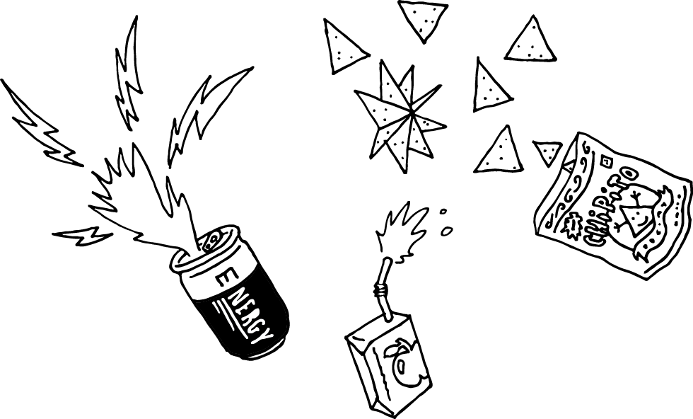

### Professional Development

**Professional Development notes**

#### Learner-Centered Instruction

Learning-centered instruction informs the entire lesson, from the first activity to the final activity. Throughout these activities, students are asked to share their existing knowledge, and to engage with the material in the lesson.

Students also work on problems that are relevant to their own lives (food, digestion, and turning food into energy).

#### Eliciting learner knowledge*:*

The activity starts with eliciting students knowledge about energy. Having students share their ideas and experiences is a useful way to begin a unit, as the teacher can incorporate students’ ideas throughout the lesson.

The lesson continues by having students share what they already know about digestion - and building on that knowledge by giving an overview of the entire digestive system.

#### Backwards planning*:*

By documenting students’ ideas on a board or whiite board, we’re able to provide a frame for the workshop topic - organizing energy by the different types of energy. We clearly articulate the goals of the unit and what we hope students will learn at the beginning of the lesson.

#### Collective Intelligence:

This activity also serves as a warm up for getting students thinking about energy and sharing their ideas with others in the class. Sharing each others’ ideas and perspectives reveals a diversity of ideas, which can be useful in working together.

#### Connecting learning to life

Linking the biology of the body with the everyday experience of nutrition and food choices helps bring context to science learning, and also helps students understand their own bodies and make healthy choices.

#### Playful approaches to learning

Having students do role plays, get up out of their seats and exercise, and engage in “hacking of snacks” are all examples of playful approaches to learning. MIT students work hard and take their classes very seriously - but they also find ways to be playful too. MIT has a culture of hacks - like dressing up the dome as R2-D2 from Star Wars or putting a fire hose next to a drinking fountain (since being a student at MIT means learning so much so fast that it is like drinking from a fire hose!). MIT has a lot of student clubs, and they often incorporate MIT into their name. The origami club is called OrigaMIT, the outdoor club is called SumMIT, and they have a summer program for high school students called MITes.

Getting students up out of their seats and moving is a great way to keep students engaged.

#### Integrating technology At MIT, we solve real world problems, and most all of our solutions involve technology. Most people associate technology with electronics, however, papers and pencils are also examples of technology!

In this lesson, we integrate activity trackers to help students learn more about how their body responds to different types of exercise. We connect that to learning technologies developed at MIT - specifically, the Makey Makey - which allows students to be part of the circuit that’s connected to the computer. Activity trackers work in a similar way - the computer is small and in the tracker, rather than being outside.

#### Strategies for handling stress MIT students have a lot of schoolwork and sometimes that creates stress! There are lots of ways students can manage this stress - yoga and meditation and even talking to other people at MIT. The concept of metacognition is important here - part of understanding your own body's reaction to stress is noticing thought processes and making sure they are positive and useful.

#### Designing solutions to open ended problems Before MIT, many colleges were focused on academics only - learning math, history, languages, arts, William Barton Rogers founded MIT to allow students to study and solve actual problems. In this lesson, we’re solving the problem of how to choose appropriate food for snacks. This represents a problem that can have a different answer for every student. Hopefully students will make healthy choices - but there are many ways to make healthy eating choices.

### 

### 

### 

### 

### Additional Resources

**Digestion resources:**

[Interactive digestion game](http://interactivehuman.blogspot.com/2008/05/digestion-interactive-game-for-kids.html) (US) - this has information on how different types of foods are digested

[Build a body game](https://www.brainpop.com/games/buildabodydigestivesystem/) - Brainpop (requires Flash)

[Interactive step by step game about digestion](http://splash.abc.net.au/res/i/L1/index.html) (Australia)

[How does our body change food into energy we can use](http://www.livestrong.com/article/496198-how-does-our-body-change-food-into-energy-we-can-use/)

[How our bodies turn food into energy](https://www.ghc.org/healthAndWellness/?item=/common/healthAndWellness/conditions/diabetes/foodProcess.html)

[How cells obtain energy from food](https://www.ncbi.nlm.nih.gov/books/NBK26882/)

This is a fun video about the Digestive System that covers this material.

[Digestive System Part 1: Crash course](https://www.youtube.com/watch?v=yIoTRGfcMqM) (11 minutes long)

**Energy and digestion:**

### [Why food is not just fuel - energy needed to digest food](http://www.huffingtonpost.com/john-berardi-phd/why-the-food-is-fuel-anal_b_6815880.html)

[Digesting protein takes more calories than digesting carbs or fats](http://www.precisionnutrition.com/digesting-whole-vs-processed-foods)

### **Whole vs. Processed food:**

[Whole food versus processed food](https://www.ncbi.nlm.nih.gov/pubmed/20613890) - difference in digestion (research report - high level science)

[Understanding whole foods](http://www.nutritionmd.org/nutrition_tips/nutrition_tips_understand_foods/whole_advantages.html)

**Snacking:**

[Smart snacking for kids](http://kidshealth.org/en/teens/healthy-snacks.html)

[Snacks and Games! Visit the Snack Shack today!](https://www.fda.gov/Food/IngredientsPackagingLabeling/LabelingNutrition/ucm490204.htm)

[Using the nutrition facts label](https://www.fda.gov/food/resourcesforyou/consumers/ucm267499.htm)

[Food calorie counter - WebMD](http://www.webmd.com/diet/healthtool-food-calorie-counter)

**Meditation:**

Headspace (download phone app or go to [www.headspace.com](http://www.headspace.com)) Guided 10 minute meditations. Great for beginners

**Technology ideas/ connections:**

Sample App Inventor Application for building your own heart rate monitor: <http://bit.ly/2qjOPs4>

**Food as Fuel**

### 1. Getting energy from food - potential energy

|  |  |  |  |  |
| --- | --- | --- | --- | --- |
| **Food** | **Selected?** | **Energy in food (Calories)** | **Energy spent to digest food type (Calories)** | **Energy left after digestion (Calories)** |
| Cheese |  | 100 | 20 |  |
| Grapes |  | 100 | 10 |  |
| Carrots |  | 100 | 5 |  |
| Cookies |  | 100 | 3 |  |
| Pretzels |  | 100 | 10 |  |
|  |  |  | **(A) Energy available for me to use (Calories)** |  |
|  |  |  | **(B) Energy used at rest, Basal Metabolic Rate** | 40 |
|  |  |  | **(C) Energy available to use (Energy in)** |  |

### 2. Using energy through exercise - kinetic energy

|  |  |  |
| --- | --- | --- |
| **Activity** | **Count (Number of seconds/Num reps etc.)** | **Energy spent (Calories)** |
| Example: Running | 10 minutes | 100 |
|  |  |  |
|  |  |  |
|  |  |  |
|  | **(D) Total energy spent (calories) (Energy out)** |  |

### 3. Energy in = energy out

|  |  |  |
| --- | --- | --- |
| **(C) Energy from food available to use** | **(D) Total energy spent** |  |
|  |  |  |

